AWS S3 Static Website Hosting

Open Amazon S3
I logged in to the AWS Management Console and opened the Amazon S3 service.

Create a bucket
I created an S3 bucket named “static-website-29-10”. A bucket is where I store the files for my website.
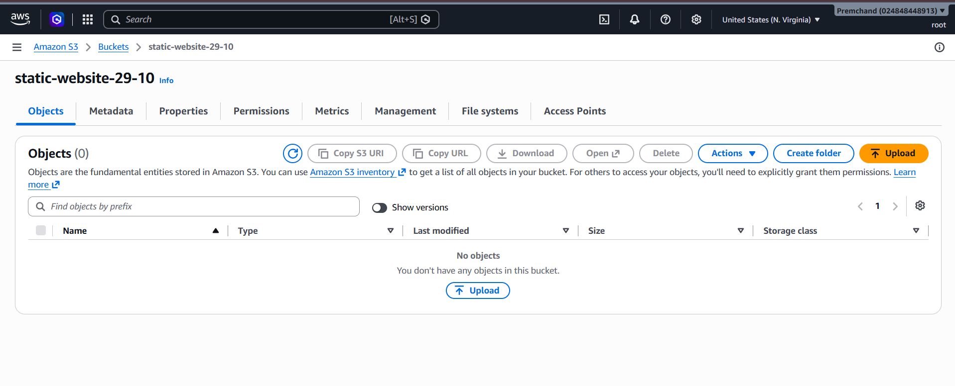

Open the bucket
After creating the bucket, I opened it and went to the Objects section. At first, the bucket was empty.

Upload the website file
I selected the upload option and uploaded my “index.html” file. After the upload finished, I checked the status and confirmed that the file was uploaded successfully.
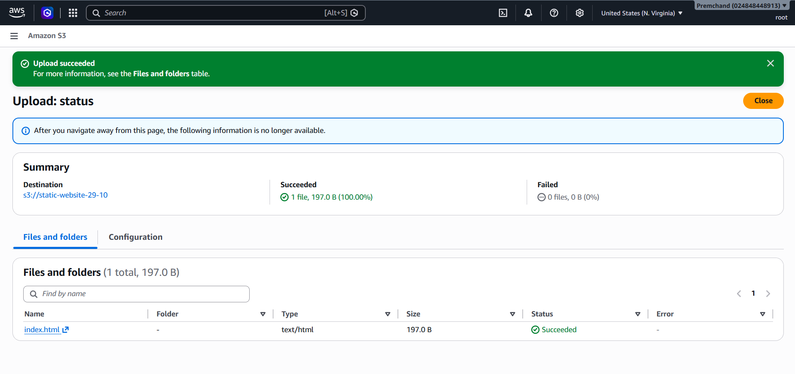

Set the bucket policy
I opened the bucket permissions and edited the bucket policy. I allowed the “s3:GetObject” action so visitors could read the website file. This permission is needed for the public webpage shown in my setup.

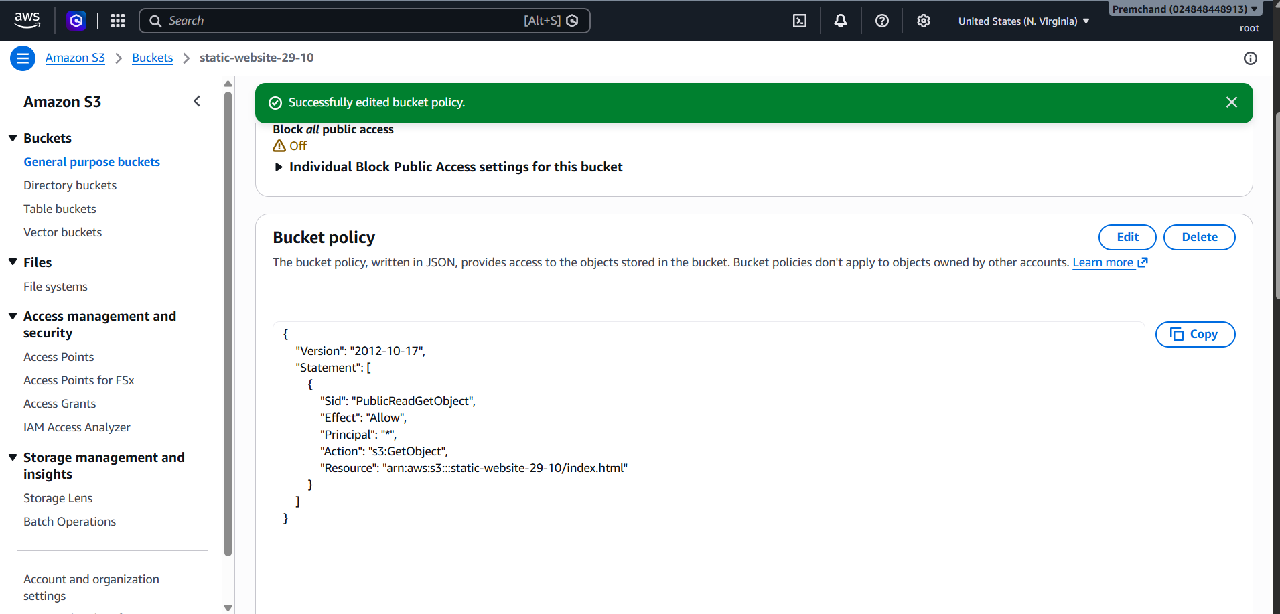

Enable static website hosting
I opened the bucket Properties, found the Static website hosting section, and enabled it. I used bucket hosting and saved the settings.

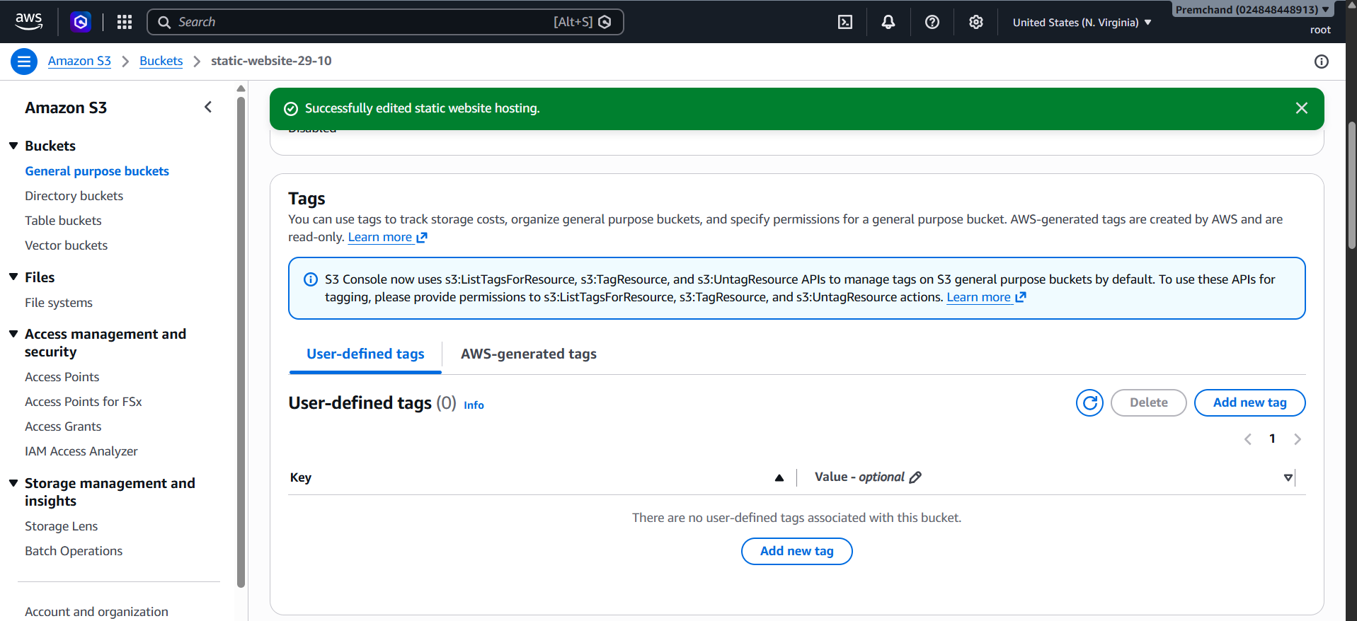

Copy the website endpoint
After enabling static website hosting, AWS displayed a bucket website endpoint. I used that endpoint to open my website in a browser.
Bucket website endpoint: http://static-website-29-10.s3-website-us-east-1.amazonaws.com

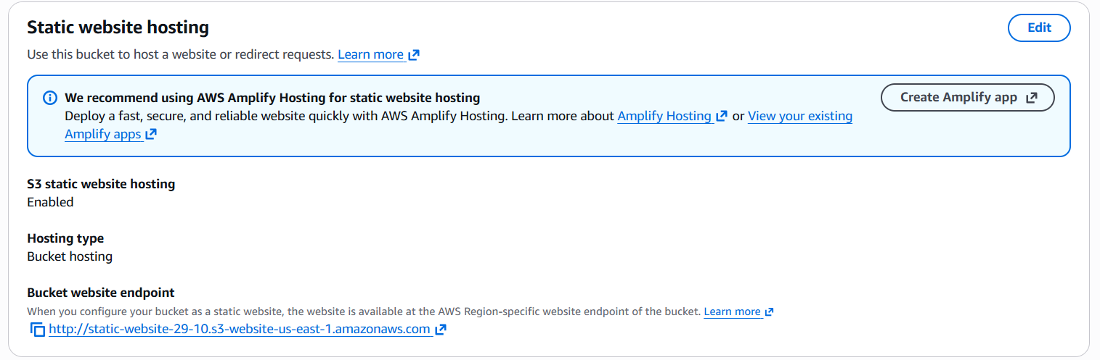

Check the website
I opened the endpoint in my browser and checked the result. The page displayed “Welcome to My Website!” and the message “This website is hosted on Amazon S3.” This showed that my HTML page was working.

